**Steps To Generate Test Suite for OrdSet.java file in Evosuite and check the mutation coverage**

* Compile Source Files:
  + Put Ordset.java file under MAIN_PROJECT\src\main\java folder structure.
  + Open command line and go to the directory where pom.xml resides.
  + If we have configured maven and evosuite properly then below mentioned command will give .class files under target folder.
    - mvn compile

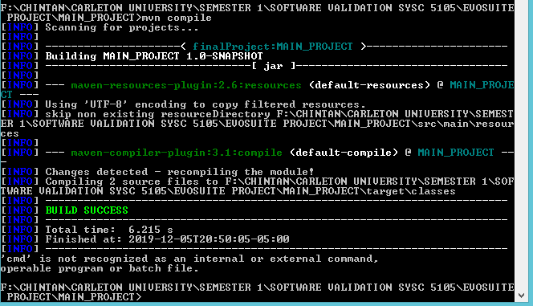

* This will generate two class files under MAIN_PROJECT\target\classes.
* Generate Test Suites for OrdSet:
  + In commandline, now type mvn evosuite:generate. This command will compile all the java source files and then it will generate the Junit tests.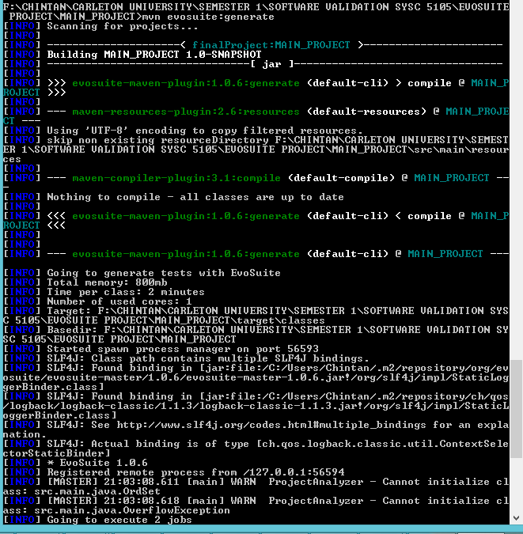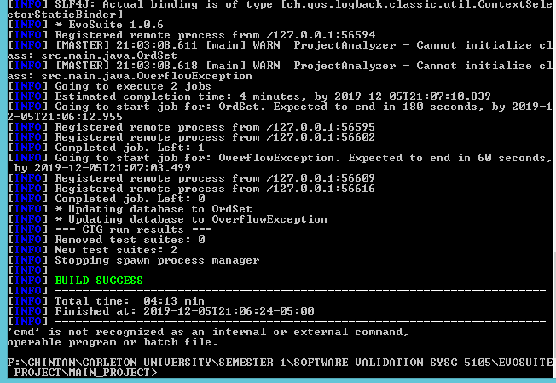
  + Under MAIN_PROJECT\.evosuite\best-tests , we will have 4 files:
    - OrdSet_ESTest.java
    - OrdSet_ESTest_scaffolding.java
    - OverflowException_ESTest.java
    - OverflowException_ESTest_scaffolding.java
  + We will put all these files under src\test\java to test the coverage.
* Mutation Testing :
  + Type mvn test in command line.

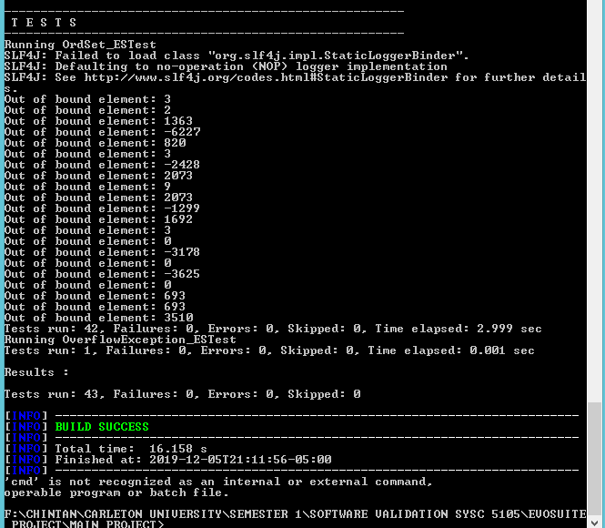

* + We will get statistics.csv file under MAIN_PROJECT\evosuite-report\OrdSet\ directory in which we will get mutation score.